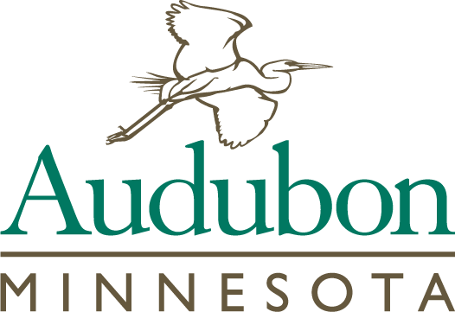
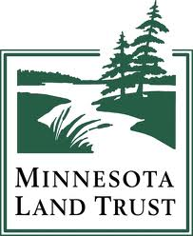
Protecting and Restoring Minnesota’s Important Bird Areas
in the Tallgrass Aspen Parklands Landowner Application

For a non-binding bid to obtain a conservation easement

This application is intended to allow landowners to voluntarily bid and compete for public funds made available through a grant provided by the Outdoor Heritage Fund, as recommended by the Lessard-Sams Outdoor Heritage Council, to preserve high quality prairie and wetland habitat in northwestern Minnesota. Bids will be prioritized based on results of a competitive bid method that considers the habitat value and the landowner bid amount to rank applications. Successful applications will be provided a one-time payment upon finalizing a conservation easement with the Land Trust.
Please complete, sign, and return this application along with a copy of your property tax statement to:
Alex Wardwell
17788 349th St. SE
Erskine, MN 56535
Or by email at awardwell@audubon.org

Landowner Name(s):__________________________________________________________________

Designated Contact Person (if different than above):__________________________________________

Mailing Address: ______________________________________________________________________

Property Address: _____________________________________________________________________

Township, Range, Section, County_________________________________________________________

Day Phone Number: ________________________Email:______________________________________

I understand that:

- A conservation easement will place permanent restrictions on the land to benefit long-term conservation.
- I may sell or transfer my property to any person or entity, but easement restrictions will permanently apply to the land.
- I am not legally committed to the easement until I sign a purchase agreement or options for the purchase of the conservation easement. Minnesota Land Trust (“Land Trust”) is not legally committed to the easement until both parties agree to, and sign, a conservation easement. The Land Trust may withdraw at any time for any reason prior to signing the final document without legal recourse by the applicants.

- That the project value score given to a property is determined by ecological factors and cost considerations. Projects with the highest prioritization rankings will be considered first, and so on, until all funds have been assigned.
- The Land Trust may not compensate landowners for more than the appraised value of the conservation easement.
- Current CRP acres may be eligible for payment if those acres will be left in permanent cover after expiration of the CRP contract.
- The Land Trust requires buffers of natural vegetation 100 feet wide along all wetlands, intermittent and perennial streams, rivers, and lakes. If the property does not currently meet the requirements of the buffers and the application is accepted, restoration of the required buffer areas must be initiated prior to closing.
- Any land intended to be kept in “agricultural use” (e.g. row crops, tree farms, orchards) will not be eligible for payment due to the wildlife habitat purpose of the funding. Land in agricultural use may not comprise more than 10% of the total acreage. Grazing or haying is subject to an acceptable management plan is not considered “agricultural use” for this provision.
- I will need to have good and marketable title to the land and that any objectionable title defects will need to be corrected at my expense. The cost of retaining an attorney or other advisors will also be at my expense.
- Any mortgage or line of credit needs to be made subject to the Conservation Easement at the closing.
- The property must meet the minimum criteria outlined in this application for the property to be eligible.
- Any payment received for a conservation easement may have tax consequences. Any value, for which you are not compensated, may potentially be considered a charitable donation.

Please provide the following information for the submission of your bid:
________ Total acres to be protected by a conservation easement.
________ Approximate acres of wetlands, ponds, lakes, streams or rivers.
________ Acres of natural upland habitat (e.g. prairie/grassland, woodlands).
________ Acres of natural habitat (e.g. prairie/grassland, woodlands) proposed to be used as pasture.
________ Is there a current grazing management plan in place? (Yes/No)
________ Acres of natural habitat proposed for haying.
________ Will the hayed acres remain as permanent cover? (Yes/No)
________ Acres currently enrolled in CRP.
________ Will these acres be left in permanent cover after expiration of the CRP contract? (Yes/No)
________ Is there an existing home site on the property or would you like to retain the right to
build a home on the property in the future? (Yes/No)
________ Enter the $ amount per acre you are requesting for the conservation easement.

Tell us about some of the special or unique features on your property (e.g. oak savanna, wetlands, marshes, lakes, prairie grouse leks etc.):

I certify that I have read, understand, and agree to each of the above statements, and the information and bid above represents an accurate description of the property and that all owners of the property are in agreement with this submitted application and bid.

Signature: ______________________________________________________________ Date: ___________________

